General Kindergarten Supply List

2023-2024

**We ask for these supplies at the beginning of the year when they are the least expensive. Experience has taught us where to ask for specific brands. Thanks for your help!**

* 2 boxes of Crayola washable markers
* 1 **thin, plastic** rest mat (labeled with name)
* 2 boxes of 8 Crayola crayons (normal size and colors please…we leave the large crayons in preschool😊)
* 4 boxes of 24 Crayola crayons (normal size only)
* 24 glue sticks (Elmers preferred)
* 1 pair of child size scissors
* 2 yellow highlighters
* 1 big pink eraser
* 1/2 inch white binder with clear plastic front
* 25 sheet protectors
* 1 regular size, hard plastic pencil box
* 1 4-pack of regular sized playdough
* 1 set of watercolor paints
* 1 pack of black Expo dry erase markers
* 1 pack of index cards (3.5 by 5)
* 1 Grade K-2 Mead Primary Journal Creative Story Tablet Notebook

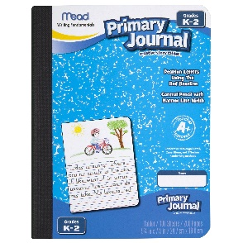

* 2 plastic/poly folders (more durable to last the entire year) with pockets & prongs
* 1 set of headphones (no earbuds please) Good quality to last all year
* 1 box of tissues
* 1 container antibacterial cleaning wipes
* Backpack (large enough to fit folder and lunchbox…no wheels please)
* Boys Only- gallon sized plastic bags (preferably NOT slide closure)
* Girls Only- sandwich sized plastic bags (preferably NOT slide closure)

**Please refer to specific teacher lists for additional supplies.**

**Gowski:**

* 1 composition notebook
* 3 – single subject wide ruled notebooks (red, green, blue)
* 1 single subject wide ruled spiral notebook (fun cover)

**Kane:**

* 4 spiral notebooks
* 1 – 16 count Crayola crayons

**Kloehn:**

* 4 additional spiral notebooks

**Mallon:**

* 1 composition notebook
* 3 single subject wide ruled spiral notebooks (red, blue, green)
* 1 single subject wide ruled spiral notebook (fun cover)

**Munro:**

* 4 single subject wide ruled spiral notebooks

**Taylor:**

* 3 wide ruled 1 subject spiral notebooks

**Sands:**

* 4 single subject wide ruled spiral notebooks

**Yoder**

* 4 additional spiral notebooks